**Policy Note**

**Is there a link between economic inequality and political stability?…well, maybe**

**Sheva Serrattan**

**March 9, 2023**

# Disclaimer

The author hopes to stimulate meaningful thought about topics that are of significant concern and relevance to society at large. This document is intended to inspire further thoughtful, data-driven research about the topic discussed, and to demonstrate different techniques and tools available for data analysis, data visualization, policy analysis and policy development. This document is not intended to used directly in any real-world decision- making.

# Contents

[Introduction (motivation) 3](#_Toc22932)

[Literature Review 3](#_Toc19831)

[Data & Sources 4](#_Toc16569)

[Data Analysis 4](#_Toc16803)

[Conclusions 6](#_Toc6281)

[Limitations 6](#_Toc2521)

[Policy Recommendations 6](#_Toc2829)

[References 8](#_Toc8821)

[Glossary 9](#_Toc31713)

# Introduction (Motivation - Defining the problem)

Economic inequality and political instability are on the rise globally, especially post-pandemic. The scope and consequences are too large to be considered within a few pages. What I create here is by no means comprehensive but is a snapshot of the considerations and implications of policy decisions.

# **Literature Review**

Economic inequality (EI) is a complex issue related to political, cultural and historical structures. There have been numerous studies on the connection between difference types of inequality and political instability, both being measured in different ways. This possible relationship has profound consequences, among other things, on economic growth, the well-being of the most vulnerable and how societies can move forward in peaceful co-existence. Ensuring political stability depends on identifying any causal relationship.

Lichbach (1989) poses the question: “*Does economic inequality breed political conflict?*” The author mentions historical examples of economic equality involved in revolution such as Iranian and Rhodesian revolutions, highlighting that inequality has been ever present, if not focal, in political conflict (PC) movements. The author has identified 43 quantitative studies which do not necessarily draw the same conclusion about the nature of the EI-PC nexus.

This paper (Lichbach, 1989) describes a model whereby economic inequality, *I*, is a function of political conflict, *C*:

***C = F(I)***

If F’ is positive then political dissent *increases* with economic inequality. Several conditions are proposed for why there could be a positive relationship, such as, disenfranchised poor resorting to force, the rich harnessing their resources to obstruct redistribution and a weak middle class. The author posits that the literature provides evidence of this as with the research of Mitchell on the Philippines, and Morgan & Clark on the United States.

In contrast, if F’ is negative, then political dissent *decreases* with economic inequality. The reasoning is the the economic elites use their power to suppress dissent. The author (Lichbach, 1989) explains that there is evidence of this also, as with research by Mitchel and Parvin.

The author (Lichbach, 1989) also puts forward a convex (U-shaped) relationship which is described as the situation where political conflict occurs at very low or very high levels of economic inequality. There is also discussion of a concave (inverted U) where political conflict occurs at intermediate levels of economic inequality due due the phenomenon of the “tendency to compare.” The remaining stylized relationship is that F’ = 0, meaning that inequality has no bearing on political dissent.

One paper (Alesina et al, 1992) examined the relationship between economic growth and political stability. While not the same, this relationship is significant in that political instability leads to uncertainty which deters investment. If economic inequality is a driver of political instability, then it is worth examining the EI-PC nexus as it has an effect on economic growth.

The findings of this study (Alesina et al, 1992) include the following:

1. As the propensity of government collapse rises, economic growth is significantly lower.
2. Contemporaneous low economic growth does not necessarily lead to an increased risk of government collapse.
3. There is no evidence of different economic growth between authoritarian and democratic governments.
4. Frequent government failures tend to predict future failures.

What is interesting about their model is that the authors use **simultaneous equations** with economic growth and political stability as dependent variables being predicted by other factors such as recent economic performance and structural institutional variables. This technique attempts to account for the endogenous nature of economic inequality. In other words, there is an assumption of circular causality between political stability and economic inequality which is very likely.

White et. al. (2017) discuss essays on economic inequality and political stability in Russia and China - two political structures which are closer to autocracy on the governance spectrum. The paper mentions several instances demonstration inequality including both countries having increasing numbers of billionaires, higher inequality in former Soviet states and a high number of government figures on private company boards exerting and benefiting from their political influence. The authors speak to the use of social contract theory by Cook and Dimitrov, to explain how autocratic regimes maintain social cohesion. The population is satisfied so long as their social, monetary, housing and consumer needs are met by the regime thus securing the political future of the current administration. When this social contract breaks down, there is consequent discord.

Other essays reviewed by White et. al. (2017) conjecture that attitudes are affected both by actual incomes and the subjective perspective of the economic distribution system. This implies that to bolster political stability, there must also be a collective sense that wealth and income is fairly allocated throughout the society. The authors conclude that there is no significant evidence that Russia and China are susceptible to political instability. The paper suggests that this is due to these regimes’ ability to provide adequate public goods and propaganda to legitimize their governments. [[1]](#footnote-0)

Malikov and Alimov (2022) examine income equality and political stability through the medium of civil society participation and use institutional quality as a moderating variable. [[2]](#footnote-1) The authors prepare a regression on unbalanced panel data of 180 countries from 1996 to 2019. They find a negative relationship between the Gini coefficient and political stability where there was low institutional quality.

The paper by Malikov and Alimov (2022) propose reasons for the impact of economic inequality on civic participation. The first is that as more resources are concentrated in the hands of a few, the poorer groups opt of political involvement (drawing from Resource Theory). The second is that because political participation requires resources, the poorer groups (with a higher opportunity cost) spends less on political influence. Lastly, the widening economic gap can lead to distrust of political institutions and disenfranchise poorer groups from participating. What is interesting is that the effect of inequality on civic involvement seems to be higher in democratic societies.

Quality of institutions is described as having to do with protection of property rights, law enforcement, corruption and human rights (Malikov and Alimov, 2022). The hypothesis is that societies with higher institutional quality give more control to market forces and results in less political instability. Lower institutional quality results in subversion of the rule of law and more political instability. The paper notes, critically, that, in determining policy, the combined effect means that countries with severe inequality and weak institutions cannot address issues regarding political stability with re-distributive policies **only** but requires reform of economic and political structures.

The basic model used by Malikov and Alimov (2022) is as follows:



The control variables, *Controlsi,t*, includes growth in GDP per capita, degree of political competition , share of population using internet, rate of inflation and youth unemployment rate. The important finding is that at low levels of institutional quality there is a stronger positive relationship between the Gini coefficient and political instability.

# **Data & Sources**

Data on the Gini coefficient and data on a particular measure of the perception of political stability were taken from the World Bank website (see definitions in the [Glossary](#_Glossary)).

Data was available for most countries from 2002 to 2020; however, values for every country for every year were not. This means that the examination uses pooled cross sectional data across time.

# **Model**

This document uses a similar but simpler methodology to that of Malikov and Alimov (2022). The econometric model is a simple linear relationship based on what discussed in Lichbach (1989):

PS = F(Gini)

Where PS = political stability measure by the World Bank, and Gini is the Gini coefficient.

# **Data Analysis**

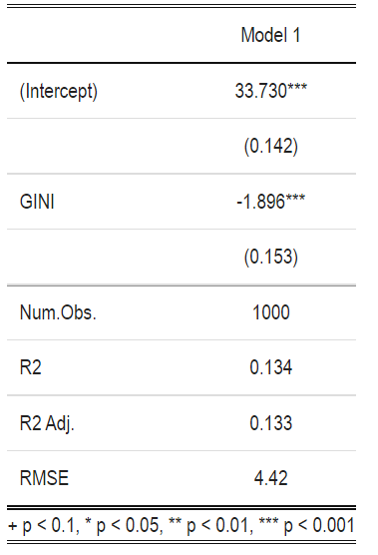

Figure 1: Output from R Studio on simple OLS model between Gini coefficient and political stability measure

The correlation coefficient is negative and significant to at least 0.1% (p < 0.001). This indicates an inverse relationship between the Gini coefficient (representing economic inequality) and the measure of political stability. The relationship between the Gini coefficient and political stability is therefore inverse. The adjusted R-squared is 0.133 indicating that only 13% of variation in political stability is explained by the Gini coefficient, meaning that there are other significant variables that affect political stability.

|  |
| --- |
| [IMG_256](https://app.powerbi.com/MobileRedirect.html?action=OpenReport%26groupObjectId=a2869f0a-3995-46c0-9cc5-fb216b98d9b6%26reportObjectId=62e2ae74-5369-48f8-938a-d6dc525d6f4e%26ctid=cc7b6fbf-0d03-45d1-bac0-3247750f917f%26reportPage=ReportSection4c8eaa0d258ed60abdb4%26pbi_source=copyvisualimage)  Figure 2: Output from Power BI visualizing Gini coefficient and political stability measure for all countries from 2002 to 2020 |
| [Open in Power BI](https://app.powerbi.com/MobileRedirect.html?action=OpenReport&groupObjectId=a2869f0a-3995-46c0-9cc5-fb216b98d9b6&reportObjectId=62e2ae74-5369-48f8-938a-d6dc525d6f4e&ctid=cc7b6fbf-0d03-45d1-bac0-3247750f917f&reportPage=ReportSection4c8eaa0d258ed60abdb4&pbi_source=copyvisualimage" \t "_blank) Political Stability Data as of 2/26/23, 1:51 AM |

Figure 2 is a visual representation of the relationship with different countries being colour coded. This visualization can be filtered by country and by year when opened in Power BI.

# **Best practice - Consider the options**

**The options**

Assuming that economic inequality has a negative correlation with political stability and the goal is to achieve increased global political stability, the following are recommended:

1. More progressive tax policy
2. Higher tax on capital gains to encourage investment in real instruments as opposed to financial instruments
3. Moderate decreases in central bank interest rates to ensure that non-viable projects are discouraged
4. Higher tax breaks for SMES
5. Increase lower income bracket for qualifying for social security (funded by capital gains tax gains)
6. What about inflation: windfall taxes - set threshold - should be based on relationship between inflation rate and profit margin of largest firms by size.

Table 1: Analysis of the alternatives

|  |  |  |  |
| --- | --- | --- | --- |
| Alternative | Criteria | Outcomes | Trade-offs |
|  |  |  |  |
|  |  |  |  |
|  |  |  |  |
|  |  |  |  |
|  |  |  |  |

[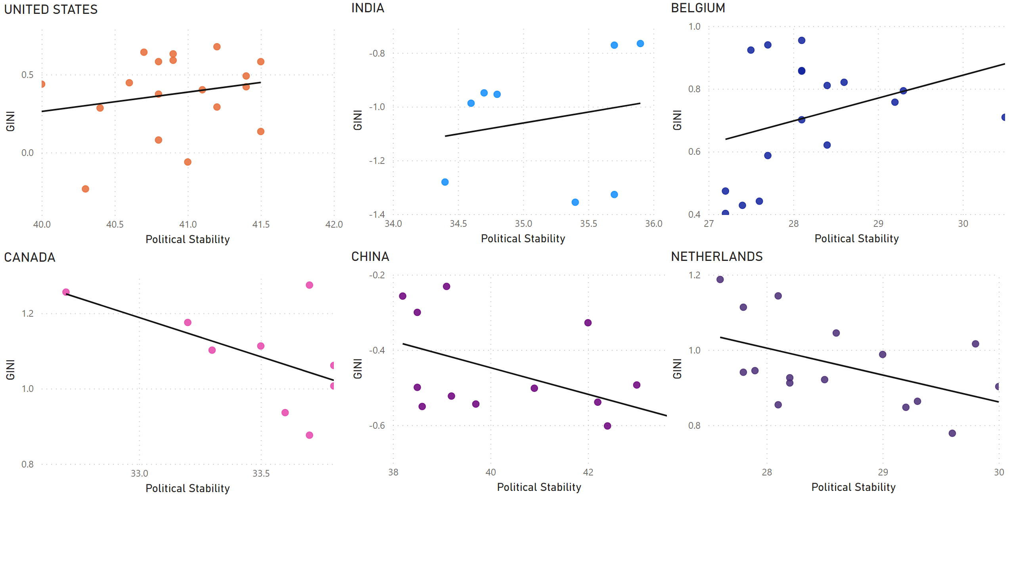](https://app.powerbi.com/groups/me/reports/62e2ae74-5369-48f8-938a-d6dc525d6f4e/?pbi_source=PowerPoint)

FIgure 3: Visualization filtered by selected countries showing disagreement of the Gini coefficient-political stability relationship among countries.

# **Conclusions**

**Summary**

**Social implications**

# **Limitations**

**Availability and quality of data**

1. Measure of political stability based on perceptions
2. Data is not complete for all countries which may bias the correlation coefficient to those countries that are more represented in the sampling.
3. Gini coefficient is based on income only - there are other types of inequality to be considered e.g. wealth, social

**Data analysis techniques**

1. Data is cross-sectional across time meaning that is is difficult to generalize
2. OLS assume a linear relationship which may not be true
3. No controls were included. Other factors may contribute to political stability. Political stability itself may be endogenous, meaning that the causality of inequality runs in both directions

**Recommendations**

While the data analysis in the paper does not provide irrefutable evidence that economics inequality, there is evidence of a possible correlation and causality. The following can improve the examinations:

1. Conduct a more extensive literature review.
2. Include controls as discussed in the data model.
3. Use lagged variables
4. Explore the use of other measures of inequality and political stability, which may be more objective.

# **Policy Recommendations**

A

# **References**

1. Alesina, Alberto, et al. “Political Instability and Economic Growth.” *Journal of Economic Growth*, vol. 1, no. 2, 1996, pp. 189–211. *JSTOR*, http://www.jstor.org/stable/40215915. Accessed 23 Feb. 2023.
2. Dutt, Pushan, and Devashish Mitra. “Inequality and the Instability of Polity and Policy.” *The Economic Journal*, vol. 118, no. 531, 2008, pp. 1285–314. *JSTOR*, http://www.jstor.org/stable/20108860. Accessed 23 Feb. 2023.
3. [https://api.worldbank.org/v2/en/indicator/SI.POV.Gini?downloadformat=excel](https://api.worldbank.org/v2/en/indicator/SI.POV.GINI?downloadformat=excel)
4. <https://databank.worldbank.org/source/worldwide-governance-indicators#>
5. Lichbach, Mark Irving. “An Evaluation of ‘Does Economic Inequality Breed Political Conflict?’ Studies.” *World Politics*, vol. 41, no. 4, 1989, pp. 431–70. *JSTOR*, https://doi.org/10.2307/2010526. Accessed 23 Feb. 2023.
6. <https://courses.lumenlearning.com/wm-microeconomics/chapter/government-policies-to-reduce-income-inequality/>
7. <https://www.oecd.org/economy/labour/49421421.pdf>
8. <https://belonging.berkeley.edu/six-policies-reduce-economic-inequality>
9. White, Stephen & Mcallister, Ian & Munro, Neil. 2017. “Economic Inequality and Political Stability in Russia and China.” *Europe-Asia Studies*. 69. 1-7. 10.1080/09668136.2016.1270580. Accessed 23 Feb. 2023.

# **Glossary**

|  |  |  |
| --- | --- | --- |
| Gini index | Gini index measures the extent to which the distribution of income (or, in some cases, consumption expenditure) among individuals or households within an economy deviates from a perfectly equal distribution. A Lorenz curve plots the cumulative percentages of total income received against the cumulative number of recipients, starting with the poorest individual or household. The Gini index measures the area between the Lorenz curve and a hypothetical line of absolute equality, expressed as a percentage of the maximum area under the line. Thus a Gini index of 0 represents perfect equality, while an index of 100 implies perfect inequality. | World Bank, Poverty and Inequality Platform. Data are based on primary household survey data obtained from government statistical agencies and World Bank country departments. Data for high-income economies are mostly from the Luxembourg Income Study database. For more information and methodology, please see http://pip.worldbank.org. |
| Political Stability and Absence of Violence/Terrorism: Estimate | Political Stability and Absence of Violence/Terrorism measures perceptions of the likelihood of political instability and/or politically-motivated violence, including terrorism. Estimate gives the country's score on the aggregate indicator, in units of a standard normal distribution, i.e. ranging from approximately -2.5 to 2.5. | Detailed documentation of the WGI, interactive tools for exploring the data, and full access to the underlying source data available at www.govindicators.org.The WGI are produced by Daniel Kaufmann (Natural Resource Governance Institute and Brookings Institution) and Aart Kraay (World Bank Development Research Group). Please cite Kaufmann, Daniel, Aart Kraay and Massimo Mastruzzi (2010). "The Worldwide Governance Indicators: Methodology and Analytical Issues". World Bank Policy Research Working Paper No. 5430 (http://papers.ssrn.com/sol3/papers.cfm?abstract\_id=1682130). The WGI do not reflect the official views of the Natural Resource Governance Institute, the Brookings Institution, the World Bank, its Executive Directors, or the countries they represent. |

1. The author of this document aknowledges that recent developments about the economies, and social and military activities in Russia and China up to March 2023, suggest that sustaining redistribution of wealth under authoritarian institutions may be challenging in the mediium to long term, leading to political instability. [↑](#footnote-ref-0)
2. This moderating variable may be important in explaining the differences in relationship between economic equality and political stability among countries. This relationship may not be easily generalized and the institutional quality may enhance, diminish or even reverse the effect. In setting public policy, this institutional uniqueness will need to be taken into account. [↑](#footnote-ref-1)